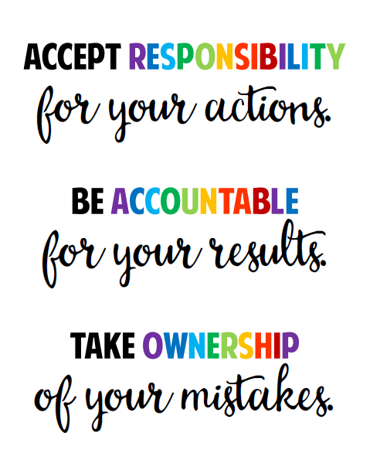

**Ten Ways to Practice Responsibility**

***Responsibility means you do the things you are expected to do, and accept the consequences of your actions.***

* Respond to the following questions in your writing journal, "What are you responsible for?" "What are ways you can show responsibility"?
* Create a chart that contains 8-10 responsible behaviors and post.
* Think about how responsibility is different in different places. What are your responsibilities at school? What are your responsibilities at home?
* Develop a "People I Know are Responsible" list and why. As you develop this, consider the key components of responsible behaviors.
* Create a story for younger children about responsibility. Share stories with younger students.
* For one week keep a daily record of all your responsibilities. Include social commitments, homework, household chores, everything. At the end of the week give yourself a grade on how well you did in carrying out your responsibilities.
* Create cartoon strips showing responsible actions.
* Talk with your family about what things you can do together to take responsibility for the environment (recycling, using less water and energy, buying non-polluting products, etc.). Make a plan and do it.
* Write about a time when you did something really responsible. Describe it. What was the outcome? How did it make you feel about yourself? Describe a time you did something really irresponsible. What was the outcome? How did it make you feel about yourself?
* Explore the differences between adult responsibilities and children’s responsibilities. What does responsibility have to do with growing up? What responsibilities do you look forward to?